Coursera Lab “Practicing Test Drive Development”

Step 1 : run tests
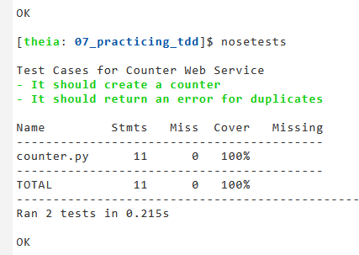

Step 2: Define additional tests

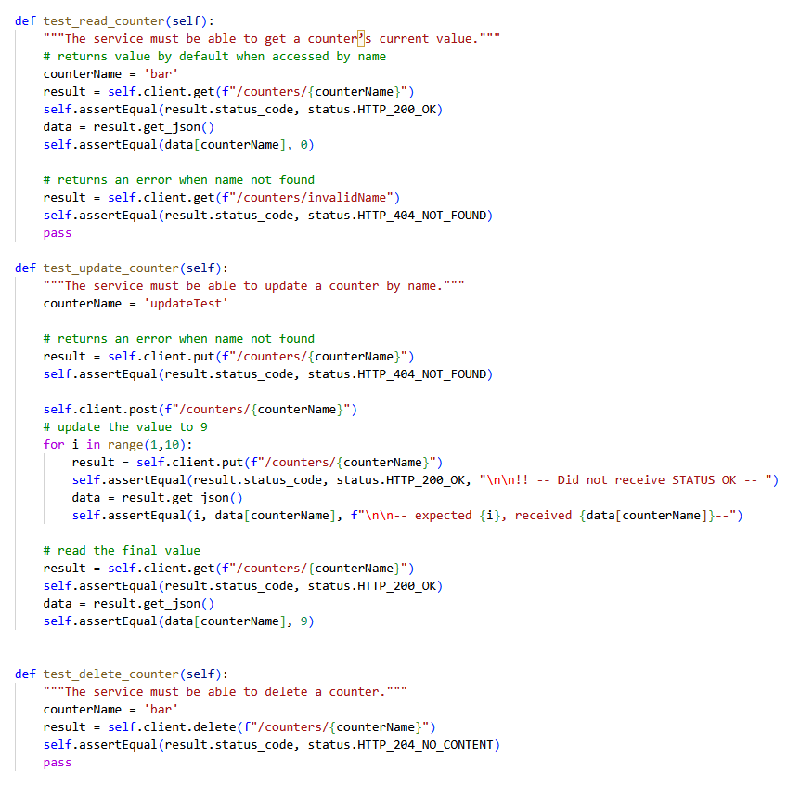

Step 3: Write code

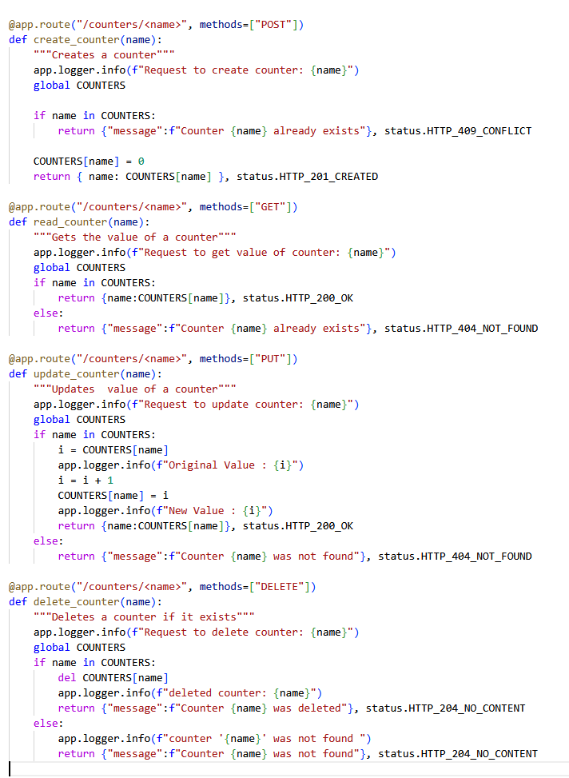

Step 4 Run passing tests

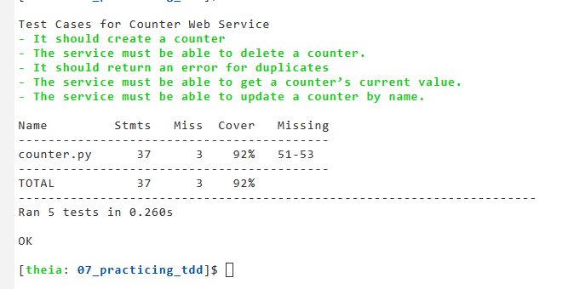
Fix Tests for code coverage:
